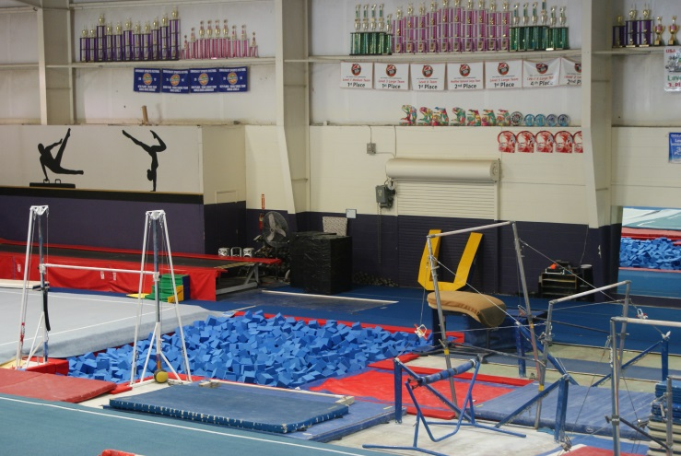
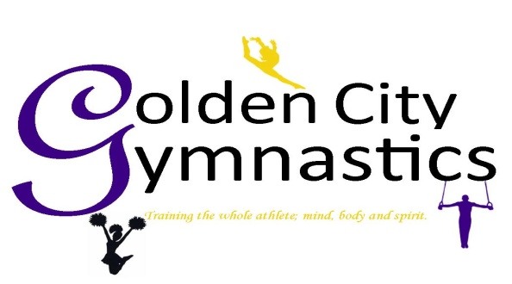
Camp Registration
Gymnast: _______________________________
Gym: __________________________________
T-Shirt Size: CS CM CL AS AM AL
2026 Competed Level: ___________
DOB: ____________________ Age: _____
Legal Guardian(s): ________________________
Please state relation: _______________________
Contact Number 1: ________________________
Contact Number 2: ________________________
Address: ________________________________
________________________________________
City: _______________ State:___ Zip: _______
Email: __________________________________
*Please print and sign a blanket waiver from our website.
Camp Fee: $450 Early Bird Offer $425
Early Bird Deadline 5.01.26
Non-refundable deposit of $100 due with registration form. Early Bird special must be paid in full by 5.01.26
Form of Payment:
__ Check __Money Order __Cash __Credit Card
If paying with Credit Card:
Name on Card: ___________________________
CC#: ___________________________________
Exp. Date: _________________ CVC: _______
Signature: _______________________________

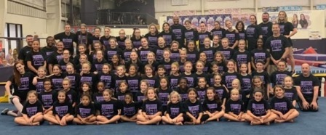
Our Facility
Golden City is a 27,000 square foot fully air-conditioned, training facility. GCG is equipped with two full sized spring floors, two 40ft Tumbl-Trak, 17 balance beams, 11 bar stations, 3 vault tables, Resi landings, a trench bar, and in-ground pit access for floor, bars, vault and beam.
In accordance with NCAA rules, our camp may limit attendance based on several factors, such as age, number and grade level. However, camp attendance is never restricted by a camper’s skill level or competitive experience.

Contact Us
Golden City Gymnastics
930 Lithia Pinecrest Rd.
Brandon, FL 33511
Phone: (813) 685-7770
Website: goldencitygymnastics.com
Email: info@goldencitygymnastics.com

Golden City welcomes you to join us in our 23rd annual Team Camp.
Kick your gymnastics into high gear this summer as you improve on old skills and learn new ones. You are not going to want to miss this camp as your skills will be taken to a new level with the use of our state-of-the-art gymnastics training center and amazing coaching staff.
Along with great gymnastics instruction, we will also have themed days, pizza party and other fun activities.

2026 Team Camp
Competitive Gymnasts
Ages 5 & Up
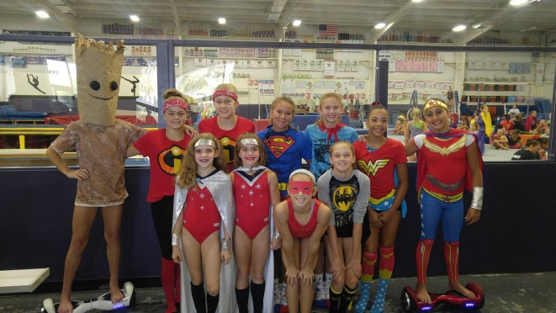
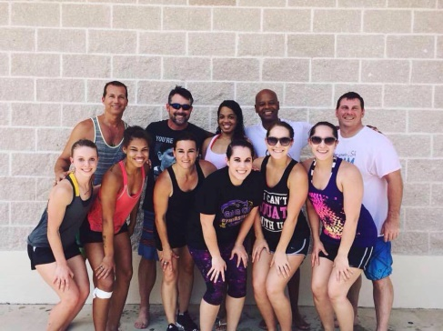
Past/Present coaching staff includes:
George Young ~ Owner MMG & Central Michigan University, Assistant Coach
Patrick Jordan ~ Gym-Nation & Wilberforce University, Assistant Coach
Valerie Mailloux ~ Livonia Gymnastics Academy
Jennifer Green ~ Air Force Academy
Christine MacDonald ~ Central Michigan University
Samantha Higgins ~ Eastern Michigan University
Morgan Byrd ~ Wilberforce University
Lori Koch ~ Former Owner of Olympia Gymnastics
Rick Tybor ~ Gulf Coast Elite Gymnastics
Dana Duckworth~ Formerly University of Alabama
Guy Thiessen-Sawka ~ Owner of Vortex Gymnastics
John Figueroa ~ Former Assistant Coach Mizzou University
Jessica Erwin ~ Naples Progressive Gymnastics
Marissa Ramos ~ GCG Optional Head Coach
Shauna Swartz ~ GCG Optional Coach
Dexter Shell ~ GCG Optional Coach
Nicole Light ~ GCG Xcel Head Coach
Colleen Tomlinson ~ GCG Compulsory Coach
Haley Salus ~ GCG Xcel Coach
Brian Zook ~ GCG Optional Coach
Brianne Mendoza ~ GCG Compulsory Coach
Richard Maijs ~ GCG Coach
Shannon Evans ~ GCG Coach
And other talented Coaches

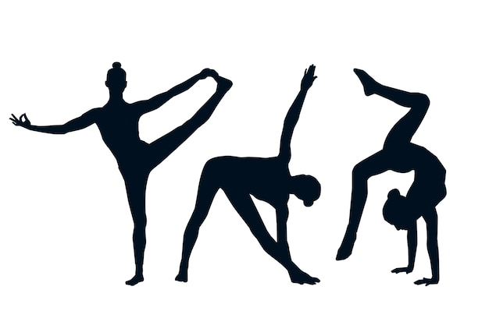
goldencitygymnastics.com

Please see our website to register for our 2026 Team Camp.
Camp Information
Camp Dates: June 27 – June 30, 2026
Camp Hours: Sat 12:00pm – 8:00pm
Sun.– Tue. 9:00am-5:00pm
Camp Eligibility: Competitive Gymnasts
Girls Ages 5 & Up
Camp Fees: $450 per gymnast
Camp Meals: Pizza provided for lunch on June 29th. All other meals not included.
Blanket Waiver: Please visit our website
goldencitygymnastics.com
and click the team camp
link to print the waiver.
What to Bring: Lunch, small healthy snacks, and all personal items such as: grips, wristbands, tape, water bottles, etc.

Camp Showcase: Our gymnasts will be putting on a show for all parents to see what the girls have been working on in camp. The showcase will be held on Tuesday, June 30th at 4:00pm.

What’s Included: A pizza lunch on Monday, June 29th & a camp t-shirt.

What to Expect
Within the 4 jam-packed days, each gymnast can expect to be pushed to their maximum potential. All athletes will be taught to their skill level on each of the Olympic events as well as strength, flexibility and dance training.

About Golden City
Golden City is committed to teaching high level gymnastics in a safe and positive environment. We focus on training the whole athlete, mind, body, and spirit. Golden City has produced numerous state, regional and national champions, collegiate scholarship winners, TOPs and HOPEs and Nastia Liukin Cup Qualifier athletes.

Themed Days
Saturday – Superhero Day (dress up like your favorite hero)
Sunday – College Day (favorite college)
Monday – Tropical Luau Day
Tuesday – Team Spirit

