ANNUAL REGISTRATION FEE
Individual Child |  | $60
Family |  | $75
MONTHLY FEES
55-minute class
1x per week |  | $98 per month
2x per week |  | $155 per month
3x per week |  | $200 per month
90-minute class
1x per week | $125 per month
2x per week | $200 per month
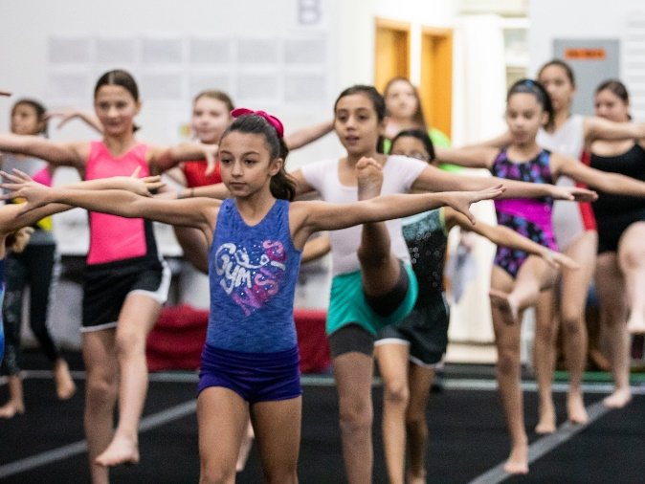
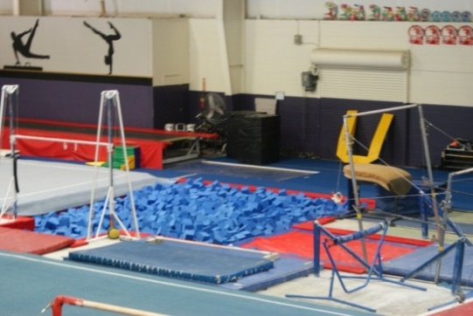



930 Lithia Pinecrest Rd
Brandon, FL 33511

813-685-7770
goldencitygymnastics.com
Golden City Gymnastics considers it a privilege to train all students in the sport of gymnastics. We are excited about gymnastics and the positive way that it will impact each child’s life!
Our Mission:
Golden City Gymnastics is committed to training the whole athlete, mind, body and spirit.
- Building a strong mind by imparting knowledge and confidence.
- Building a strong body through physical conditioning and exercise.
- Building the Spirit through encouragement and faith-based principles.





Avengers / Boys / 6yrs & up / 55 minutes
Tuesday: 5:00 / 7:00
Thursday: 5:10 / 6:10

Teen Green Gymnastics / Girls / 11-18yrs / 1 ½ hours
(Specific skills required to enter)
Tuesday: 6:30

Teen Gymnastics / Girls / 12-18yrs / 55 minutes
Monday: 7:30
Wednesday: 7:30

Youth Tumblers / Coed / 6-11yrs / 55 minutes
Beginner:
Tuesday 6:00
Wednesday: 4:00

Advanced:
Tuesday 7:00

Teen Tumblers / Coed / 12-18yrs / 55 minutes
Thursday: 7:00

Red / Girls / 6yrs & up / 55 minutes
Mon: 3:00 / 3:10 / 3:50 / 5:00 / 5:50(8+) / 6:30 / 6:50 / 7:10
Tue: 4:10 / 5:10 / 5:20 / 6:00 / 6:20 / 6:50
Wednesday: 4:00 / 5:20
Thursday: 3:50 / 4:50 / 5:50 / 6:50
Friday: 4:00 / 5:00 / 6:20 / 7:00
Saturday: 12:00

Orange / Girls / 6yrs & up / 55 minutes
(Specific skills required to enter)
Monday: 4:10 / 5:10 / 6:00
Tuesday: 4:20 / 6:10 / 7:10
Wednesday: 4:20 / 5:00 / 5:40 / 6:40
Thursday: 4:20 / 6:10 / 7:00
Friday: 6:00
Saturday: 10:00

Yellow / Girls / 6yrs & up / 55 minutes
(Specific skills required to enter)
Monday: 4:00 / 5:40 / 7:00
Tuesday: 5:00 / 6:30
Wednesday: 4:40 / 6:20
Thursday: 4:00 / 5:20
Friday: 5:20
Saturday: 11:00

Green/Teal/Blue/Purple / Girls / 6yrs & up / 1 ½ hours
(Specific skills required to enter)
Monday: 3:30 / 5:00
Tuesday: 5:30
Wednesday: 6:00
Thursday: 4:20 / 6:00
Friday: 5:00 / 6:30

Little Comets / Coed / 1.6yrs - 2.11yrs / 45 minutes
Saturday: 9:00

Asteroids / Coed / 3.0yrs - 4.5yrs / 55 minutes
Monday: 4:00 / 6:00
Tuesday: 4:50 / 5:00 / 5:50
Wednesday: 6:00
Thursday: 3:00 / 4:00 / 5:40
Friday: 4:30
Saturday: 10:00

Explorers / Coed / 3.0yrs-5.11yrs / 55 minutes
Monday: 3:00 / 4:50
Tuesday: 3:00
Wednesday: 6:40
Friday: 3:30
Saturday: 12:00

Skyrockets / Coed / 4.6yrs-5.11yrs / 55 minutes
Monday: 5:00 / 6:10
Tuesday: 3:30 / 4:00 / 4:30 / 6:00 / 7:00
Wednesday: 4:00 / 5:30 / 6:10
Thursday: 5:00 / 6:00 / 6:20
Friday: 5:30
Saturday: 11:00

Cosmos / Coed / 4.0yrs - 5.11yrs / 55 minutes
(Specific skills required to enter)
Monday: 6:40
Wednesday: 5:00

